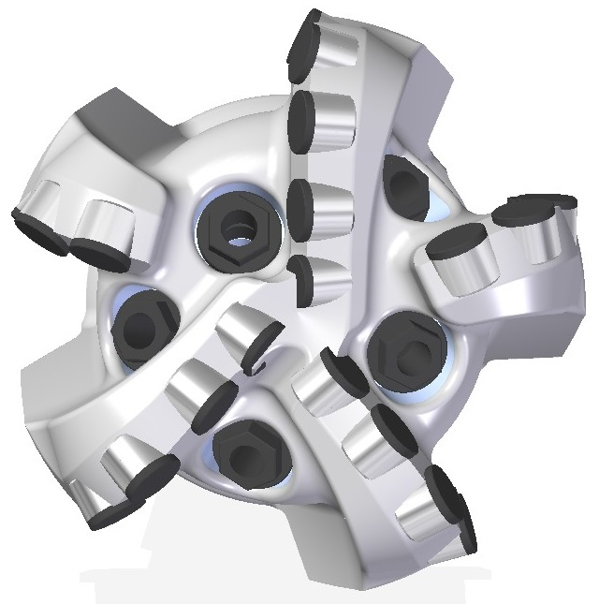 |  | 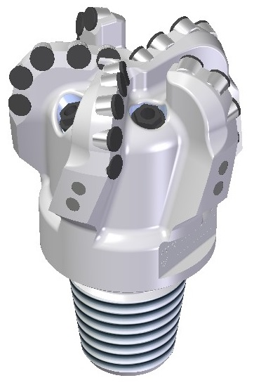

Drill Bit Specifications:
Cutter Size (Primary, Sec) | 5/8”,1/2”
Cutter Count (Total, Gage) | 21,1
Blade Count | 5
Gage Length (Inches) | 1.50
Nozzle Count (Primary, Sec.) | 5
Nozzle Series (Primary, Sec.) | 55
JSA (Sq. Inches) | 10.1
Max. TFA (Sq. Inches) | 0.98
Operating Parameters:
Max. Hydraulic Flow Rate (GPM) | 306
Max. Weight on Bit (1,000 Lbs.) | 25
Make-up Torque (ft/lbs) | 8913
Nominal Dimensions:
Overall Length (Inches) | 10.0
Make Up Length (Inches) | 6.25
Bit Breaker | SKB-21012
Connection | Ø3-1/2" API Reg.
Approx. Weight (Lbs.) | 35

Standard Features:

- Large open face volume assists cuttings removal
- Five nozzles optimize blade cleaning and cuttings removal
- Premium grade cutters maximize ROP and Life

516-SR Nomenclature Explained:

- 5 = Number of Blades
- 16 = Primary Cutter Size (16mm)
- SR = Single Row Cutters

